Module.exports vs exports

Modularity is a key principle of software engineering. It means that we must segregate our code in separate units. Each of these units put together make up our application. A separate unit of code is easier to debug, maintain and share for re-usability. In this article, we will learn how ‘module.exports’ and ‘exports’ are used in JavaScript to enable modularity.

Modules in nodeJS
Modules are re-usable pieces of code which can be shared within an application and also in external applications using a package manager like NPM.
To understand a modular application or modules in JavaScript, lets imagine a CPU. A CPU is not a single machine. Rather, it is a combination of various parts like the motherboard, the processor, the memory etc. When we need more storage, we can simply install more storage. If we have heating issues, we can simply repair or replace the cooling fan. No matter the issue, we don’t need to change the whole CPU. Think of the CPU parts as JavaScript modules and the CPU as a nodeJS application. Thus, a module is simply a file that exports some piece of code. A module is re-usable and for an application, the developers can work in isolation on the modules if anything breaks. This in turn brings good organization to the software. There is also another big issue that moduling solves. When not using modules, there is a big risk of exposing all of our code to the global scope. This means that unnecessary properties will get exposed to the end user. This is a not only a design flaw but also a security flaw.

What makes a good moduling system ?
There are various ways to add modularity capabilities to a programming language. However we can define a few important standards.
A module standard must have the following features :
- File Distribution : We must be able to divide our code into separate files. It will benefit us little if we can only divide the code into separate data structures and functions. Files make it easier to share and maintain the code. It also helps to decrease the codebase size.
- Importing & Exporting : There must be a functionality to import and export specific parts of the modules. Here we have the option to export all properties of a module or choose which one to export.

CommonJS Modules and ES6 Modules
The above mentioned standards were used to develop two standards for moduling in JavaScript - CommonJS and ES6 Modules. CommonJS is the older of the two and prevents exposing unnecessary code to the global scope. Both standards use the file based importing and exporting for modules. CommonJS is the older of the two. It is widely known and used since it is implemented in Node.JS out of the box. This means that all CommonJS functionality is built into Node.JS natively. However, the downside to this is that Browsers do not support CommongJS out of the box. Also, CommonJS is synchronous. The modules are loaded synchronously. Since, JavaScript is a single-threaded language, a synchronous module import will block the code. In more technical terms, the JavaScript call stack is frozen for the duration of a synchronous process and no other code execution takes place until this process is finished. The solution to this problem would be to use a module bundler like WebPack. It should be noted that CommonJS is not the official standard for JavaScript. There is no ECMA script specification for CommonJS.
The official standard was later developed and came to be known as ES6 Modules or ES Modules (ES stands for EcmaScript). This new module standard, released in 2015, was baked into the native JavaScript language. This meant that a runtime environment like Node.JS was not required for the module functionality for JavaScript. ES Modules support asynchronous loading out of the box. It was non-blocking in nature which is an upgrade from the CommonJS functionality. Browsers also support ES Modules which means there is no need for a module bundler.
It is this difference between CommonJS and ES Modules which becomes the baseline for the difference between “module.exports” and “export”.
Module.Exports
This is the export declaration for CommonJS. Module is an object. Here is how it looks if we log it in the console.
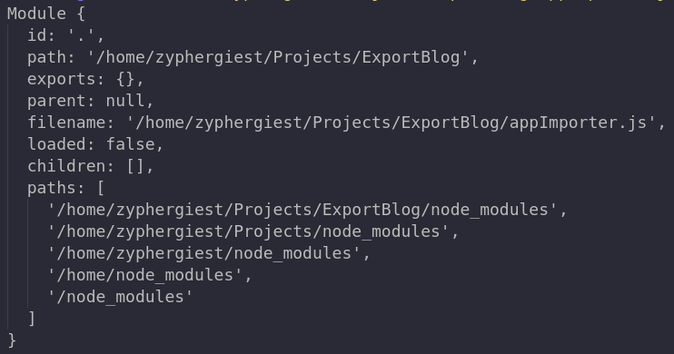
As we can see, “exports” is an object within module. We can assign the properties which we want to export to this module.exports object. This can be done in the following ways :
Default Export Method : Here we assign the module.exports object to our desired property.
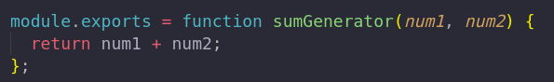
Named Export Methods : Here we assign specific properties or we can also use an object :
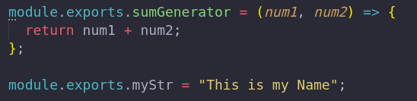
We can also use a object :
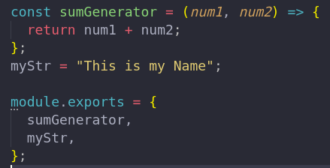

Now if we check the log for the module object :
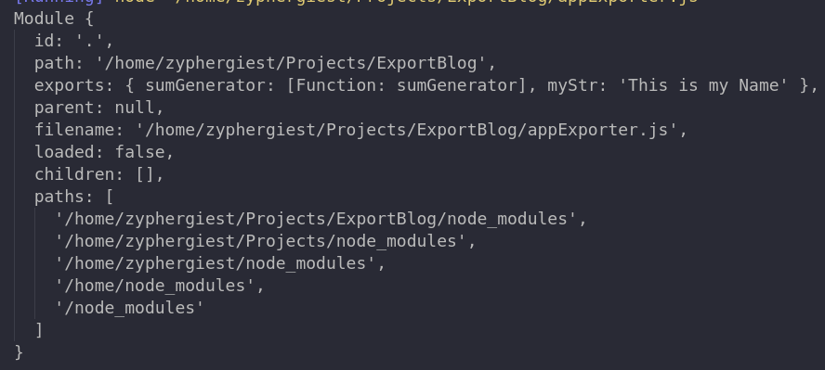
As we can see, the exports object was empty earlier but now has been populated with our properties.
The properties that we have exported can be imported using the “require” keyword.

Export
The “export” declaration is for the ES Modules. Here is how we can use this :
## Named export : Export for individual properties ( multiple per module )
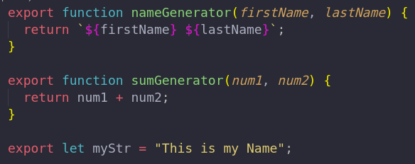
## Default export : A single export which is either a single property or a default export object. (single per module)
>> insert img
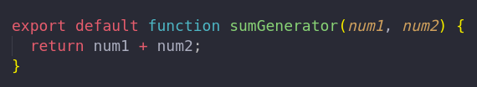
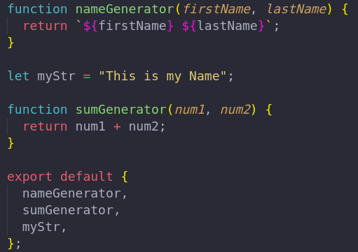

Which one should we choose ?
As most answers in the software sphere, it depends! Definitely using the newer ES Modules is a better alternative moving forward and it is the right path for the future. All new applications are implementing the ES Modules standard. However, CommonJS is still supported by NodeJS and widely used even today. So, there is a good chance that we may need to continue maintaining an application using CommonJS.

Conclusion :
- A Module is a shareable piece of code which can be exported and imported in internal and external applications to ensure re-usability. Modules are isolated and they help to organize our code. They also make the code easier to debug and maintain. A good module standard helps to solve the Global Scope issue along with being file based and capable of exporting and importing properties.
- Module.Export is used for CommonJS standard which is integrated into the Node.JS runtime environment. It is not recognized by browsers and it is generally used for server side JavaScript.
- Export is used for ES Modules standard which is integrated into JavaScript itself. It is recognized by browsers and can be used for server side and client side JavaScript.

